Task 8: Data Versioning and Lineage
RecoMart — End-to-End Data Management Pipeline for a Recommendation System
Data Management for Machine Learning (AIMLCZG529/DSECLZG529), S2-25
This document has three parts: (1) how we versioned our data using DVC, (2) a data lineage report tracing our data end to end, and (3) a consolidated log of every transformation applied across the pipeline.

Part 1: Versioning Workflow

1. Why We Needed a Versioning Approach
Our raw data source (the Kaggle REES46 clickstream CSV) is large - about 5.28 GB uncompressed. Our ingestion script (ingest_kaggle_batch.py, from Task 2/3) is designed to run repeatedly over time, writing each run's data into a new timestamp-partitioned folder (ingestion_date=YYYY-MM-DD/) rather than overwriting the previous one. This already gives us multiple versions of the raw data sitting on disk. Task 8 asks us to formally track and document these versions using a tool like DVC or Git LFS.

2. Why We Chose DVC Over Git LFS
We initially tried Git LFS, since it's simpler to set up and works directly with GitHub. However, we ran into a hard limitation: GitHub's free tier caps LFS storage and bandwidth at 1 GB, and our raw CSV alone is 5.28 GB per version. Attempting to push it resulted in a failed push, and having two versions (July 9 and July 12) would have meant over 10 GB total - nowhere close to feasible on the free tier.
DVC solves this differently: instead of uploading the actual large file anywhere, it creates a small pointer file (a .dvc file, only a few hundred bytes) containing a hash/fingerprint of the data. Only this tiny pointer file goes into Git - the real data stays on our local machine. This let us version the dataset without hitting any size or bandwidth limits.

3. What We Actually Did
We extended DVC tracking across both data sources and all four pipeline stages, so that every dataset genuinely has version history behind it rather than just the raw Kaggle layer:
Dataset Stage | Versioned? | What We Tracked
Raw Dataset (Kaggle) | Yes | 2019-Oct.csv, two dated versions (ingestion_date=2026-07-09 and 2026-07-12)
Raw Dataset (FakeStoreAPI) | Yes | products_200250.json - the raw API response, timestamp-partitioned the same way as Kaggle
Validated Dataset | Yes | validation_summary.json - results of our Task 4 checks (row/column counts, missing values, duplicates, negative price count)
Cleaned Dataset | Yes | clickstream_transactions_prepared.csv - the deduplicated, encoded, normalized output of Task 5
Feature Dataset | Yes | user_features.csv, item_features.csv, product_co_occurrence.csv - engineered features from Task 6
Product Catalog (FakeStoreAPI, processed) | Yes | product_catalog.csv - the normalized FakeStoreAPI reference table, saved from the database and tracked
Steps taken, in order:
git init # initialized Git in our working folder
dvc init # initialized DVC (requires a Git repo to sit inside)
dvc add "...ingestion_date=2026-07-12\2019-Oct.csv" # Raw Dataset - Kaggle (July 12)
git commit -m "Task 8: Initialize DVC tracking for raw data (2026-07-12 ingestion)"
dvc add "...ingestion_date=2026-07-09\2019-Oct.csv" # Raw Dataset - Kaggle (July 9)
git commit -m "Task 8: Track July 9 raw data version with DVC"
dvc add "...processed\clickstream_transactions_prepared.csv" # Cleaned Dataset
git commit -m "Task 8: Version cleaned/prepared dataset with DVC"
dvc add "...processed\user_features.csv" "...item_features.csv" "...product_co_occurrence.csv" # Feature Dataset
git commit -m "Track Task 6 feature engineering outputs with DVC"
dvc add "...processed\validation_summary.json" # Validated Dataset
git commit -m "Task 8: Version validation summary (Validated Dataset stage)"
dvc add "...streaming\product_catalog\...\products_200250.json" "...processed\product_catalog.csv" # Raw + processed FakeStoreAPI data
git commit -m "Task 8: Version FakeStoreAPI raw data and product_catalog with DVC"
Each dvc add command produced a small .dvc file next to the real data file, and DVC also automatically added a .gitignore rule so that Git would never accidentally try to track the actual data files themselves, only the small pointers.
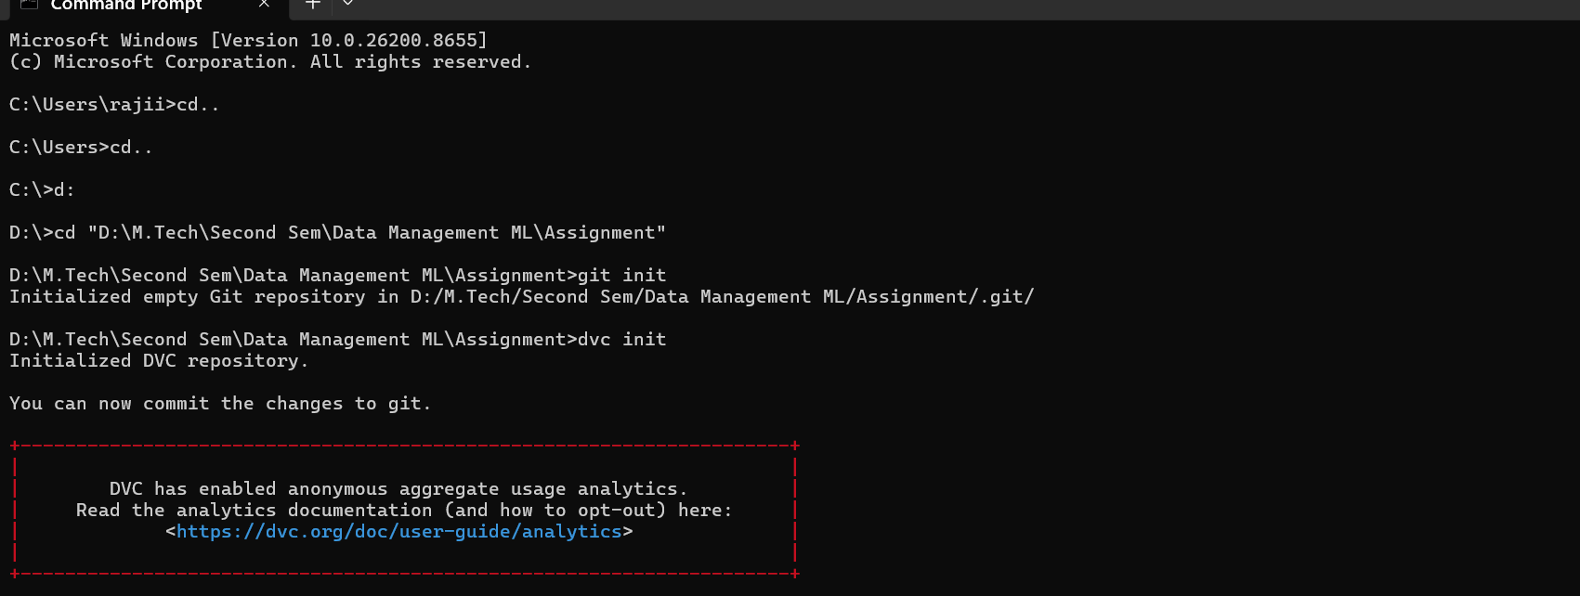
Screenshot: git init and dvc init running successfully in our project folder.
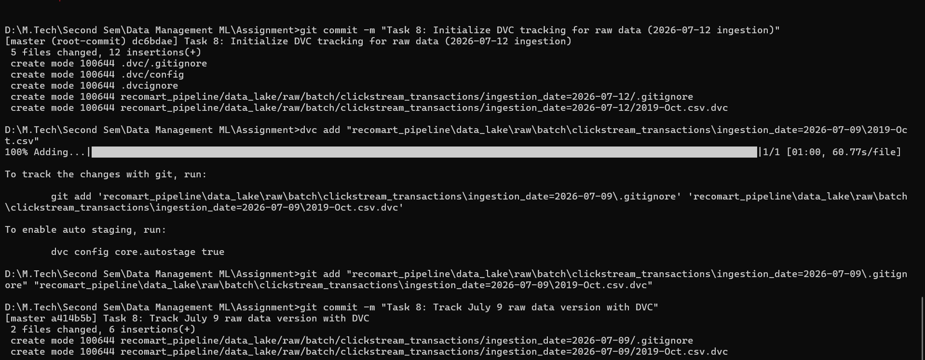
Screenshot: dvc add completing on the raw CSV (5.28 GB, ~1 minute to process), followed by git add and git commit saving the version.

4. Resulting Repository Structure
Our Git commit history now shows six commits, covering both data sources (Kaggle and FakeStoreAPI) across all pipeline stages:
8538c68 (HEAD -> master) Task 8: Version FakeStoreAPI raw data and product_catalog with DVC
cfd49ec Task 8: Version validation summary (Validated Dataset stage)
92cc567 Track Task 6 feature engineering outputs with DVC
c746012 Task 8: Version cleaned/prepared dataset with DVC
a414b5b Task 8: Track July 9 raw data version with DVC
dc6bdae Task 8: Initialize DVC tracking for raw data (2026-07-12 ingestion)
Each .dvc file contains a content hash of its corresponding data file. This means if any dataset changed between runs, the hash in a newly-added .dvc file would differ, giving us a verifiable way to detect and confirm that the data actually changed, not just that a new file was created.

4b. Verification
To confirm the versioning was actually saved (not just run once and forgotten), we re-ran git log --oneline in a fresh terminal session and got the same commits back, confirming the history is genuinely persisted in our local Git repository:
8538c68 (HEAD -> master) Task 8: Version FakeStoreAPI raw data and product_catalog with DVC
cfd49ec Task 8: Version validation summary (Validated Dataset stage)
92cc567 Track Task 6 feature engineering outputs with DVC
c746012 Task 8: Version cleaned/prepared dataset with DVC
a414b5b Task 8: Track July 9 raw data version with DVC
dc6bdae Task 8: Initialize DVC tracking for raw data (2026-07-12 ingestion)
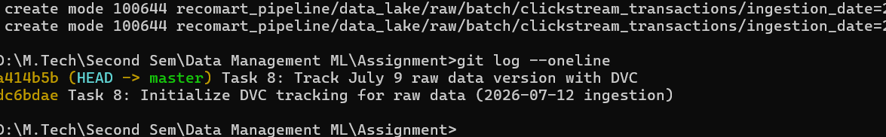
Screenshot: git log --oneline re-run in a fresh terminal session, confirming both commits are genuinely persisted.

5. Metadata Tracked
Metadata | How It's Tracked
Data source | Kaggle REES46 e-commerce clickstream dataset
Date of ingestion | Captured directly in the folder name (ingestion_date=YYYY-MM-DD), created automatically by ingest_kaggle_batch.py each time it runs
Applied transformations | Not applied at the raw layer (raw data is kept untouched, per our Task 3 approach). Transformations are tracked separately via our Task 6 SQL schema and Task 7 feature registry, and consolidated in Part 3 of this document
Version identity | Content hash stored inside each .dvc pointer file, plus the Git commit message and commit hash

6. Local Storage Note
The .dvc pointer files (and the version history they represent) are pushed to GitHub as part of our repository, so anyone can see exactly how many versions exist, when each was created, and their content hashes. The actual raw data files stay on the local machine they were ingested on, since DVC is designed to separate 'tracking metadata' (small, goes in Git) from 'actual data' (large, stays wherever it is). For a production setup, DVC supports connecting a remote storage backend (S3, Google Drive, Azure Blob, etc.) so the real data could be pulled by anyone with access to that remote - we kept this local-only since it fully demonstrates the versioning mechanism Task 8 asks for, without needing to set up and pay for external cloud storage for a class assignment.

Part 2: Data Lineage Report
This section traces where our data came from, what happened to it at each stage of the pipeline, and where it ended up - end to end, across both data sources (Kaggle REES46 and FakeStoreAPI).

Source A: Kaggle REES46 Clickstream Data
Stage | Location / Table | What Happens Here | Traces Back To
Source | External: Kaggle REES46 dataset | 5.28 GB CSV of e-commerce clickstream events (view/cart/purchase) | Original download, no traceable predecessor
Raw ingestion | data_lake/raw/batch/clickstream_transactions/ingestion_date=.../ | Copied via ingest_kaggle_batch.py, untouched, timestamp-partitioned. Two versions exist: 2026-07-09 and 2026-07-12 | Kaggle source file
Validation | Datapipeline.ipynb, Task 4 cells | Schema checks, missing value counts, duplicate detection, range checks run against the raw sample | Raw ingested file
Preparation / cleaning | data_lake/processed/clickstream_transactions_prepared.csv | Duplicates removed (500,000 to 499,712 rows), missing values handled, categorical encoding, normalization | Validated raw file
Feature engineering | PostgreSQL: user_features, item_features, product_co_occurrence | user_activity_count, engagement scores, co-occurrence pairs calculated from cleaned data | Prepared/cleaned dataset
Feature registration | PostgreSQL: feature_registry | Each feature's name, source, transformation, datatype, and version recorded | Feature tables above

Source B: FakeStoreAPI Product Data
Stage | Location / Table | What Happens Here | Traces Back To
Source | External: FakeStoreAPI (fakestoreapi.com/products) | Live REST API, 20 products with title, category, price, rating | Original API, no traceable predecessor
Raw ingestion | data_lake/raw/streaming/product_catalog/ingestion_date=.../ | Polled via ingest_fakestore_api.py, saved as timestamped JSON per call. DVC-tracked (products_200250.json, 2026-07-12) | FakeStoreAPI response
Validation | Datapipeline.ipynb, Task 4 cells (FakeStoreAPI section) | Missing values, duplicate product IDs, rating range (0-5) checks | Raw JSON file
Preparation / cleaning | df_products (in-notebook), Task 5 cells | rating.rate / rating.count extracted from nested field, price and rating min-max normalized | Validated raw JSON
Enrichment merge | df_clean.category_avg_rating_enrichment (Task 6) | Category-mapped and merged into REES46 data as an external rating signal, with fallback for unmatched categories | Cleaned FakeStoreAPI data + cleaned REES46 data
Final storage | PostgreSQL: product_catalog; also saved and DVC-tracked as product_catalog.csv | Normalized FakeStoreAPI reference data stored as its own table and file | Cleaned/normalized FakeStoreAPI data

Lineage (Text Form)
Kaggle REES46 (source) -> raw/batch/ (2 dated versions, DVC-tracked) -> validated -> cleaned/prepared -> engineered features -> feature_registry -> PostgreSQL feature tables
FakeStoreAPI (source) -> raw/streaming/ (timestamped JSON) -> validated -> cleaned/normalized -> merged into REES46 as enrichment, and also stored standalone as product_catalog
Both paths converge at the PostgreSQL database (recomart / recomart_v2.db), which is the single source of truth for all downstream work (feature store, and eventually model training).

Version Traceability
The raw Kaggle data specifically has two tracked versions (ingestion_date=2026-07-09 and ingestion_date=2026-07-12), each with its own DVC content hash and Git commit (see Part 1 for the exact commit hashes and verification screenshots). This means any downstream feature can, in principle, be traced back not just to 'the Kaggle dataset' generally, but to the exact dated raw file version it was computed from.

Part 3: Pipeline Processing Log
This is a consolidated, chronological log of every transformation step applied to our data across the pipeline, from raw ingestion through feature registration. Ingestion-level logs (success/failure, retries, record counts) are captured automatically by our scripts in the logs/ folder (kaggle_ingestion_*.log, fakestore_ingestion_*.log); this section consolidates the processing steps that happened afterward, inside the notebook, which weren't otherwise logged to a file.
Task | Step | Transformation Applied | Input -> Output | Tool / Script
2 | Kaggle batch ingestion | File copied as-is from source to raw/batch/, no data altered | Source CSV -> raw/batch/.../2019-Oct.csv | ingest_kaggle_batch.py (logged to kaggle_ingestion_*.log)
2 | FakeStoreAPI ingestion | API response saved as-is, no data altered | API JSON response -> raw/streaming/.../products_*.json | ingest_fakestore_api.py (logged to fakestore_ingestion_*.log)
4 | Kaggle validation | Schema check (9/9 columns), missing value profiling, duplicate detection, price/event_type range checks, timestamp format check | Raw CSV sample (500,000 rows) -> validation report | pandas, Datapipeline.ipynb
4 | FakeStoreAPI validation | Missing value check, duplicate product_id check, rating 0-5 range check | Raw JSON -> validation report | pandas, Datapipeline.ipynb
5 | Deduplication | Full-row duplicates dropped | 500,000 rows -> 499,712 rows | df.drop_duplicates(), pandas
5 | Missing value handling | category_code and brand missing values handled (31.69% / 14.37% missing respectively) | 499,712 rows (with nulls) -> 499,712 rows (nulls handled) | pandas
5 | Encoding & normalization | Categorical attributes encoded; price and rating normalized (FakeStoreAPI side) | Cleaned raw data -> prepared dataset | sklearn LabelEncoder/MinMaxScaler
5 | Output | Prepared dataset saved | In-memory df_clean -> clickstream_transactions_prepared.csv | pandas to_csv
6 | User activity feature | Grouped by user_id, counted interactions | df_clean -> user_activity_count (89,124 users) | pandas groupby
6 | Item engagement features | Weighted event scoring (view=1, cart=2, purchase=3), grouped by product_id | df_clean -> total_interactions, total_engagement_score, avg_engagement_score (46,897 products) | pandas groupby
6 | Category enrichment | REES46 categories mapped to FakeStoreAPI categories; average rating merged in, with fallback for unmatched | df_clean + df_products -> category_avg_rating_enrichment (100% coverage, 499,712 rows) | custom mapping function, pandas merge
6 | Co-occurrence calculation | Binary user-product matrix built, transpose-multiplied, reshaped to long format, self-pairs removed | Top 20 products -> product_co_occurrence (380 rows) | pd.crosstab, matrix multiplication
6 | Database load (SQLite) | Feature tables created and loaded per recomart_schema.sql | In-memory DataFrames -> recomart_v2.db | sqlite3, pandas to_sql
6 | Database load (PostgreSQL) | Same schema and data loaded into a live SQL server | In-memory DataFrames -> PostgreSQL: recomart | SQLAlchemy, psycopg2
7 | Feature registration | 9 features registered with name, source, transformation logic, datatype, description, version | Feature tables -> feature_registry (PostgreSQL) | pandas to_sql
7 | Versioning demo | avg_engagement_score re-registered as v2 with revised weights (view=1, cart=3, purchase=5); v1 marked inactive but retained | feature_registry v1 -> feature_registry v1 + v2 | SQLAlchemy
8 | Raw data versioning | Two dated raw file versions (2026-07-09, 2026-07-12) tracked as content-hashed pointers | Raw CSV files -> .dvc pointer files + Git commits | DVC, Git

Notes
Steps are listed in the order they occur in the pipeline (Task 2 through Task 8), not necessarily the order cells appear in the notebook if any exploratory/EDA cells were run out of strict sequence. Row counts and coverage percentages shown match the actual output from Datapipeline.ipynb at the time each step was run.

